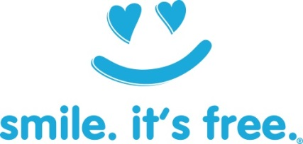
3rd Annual Event!
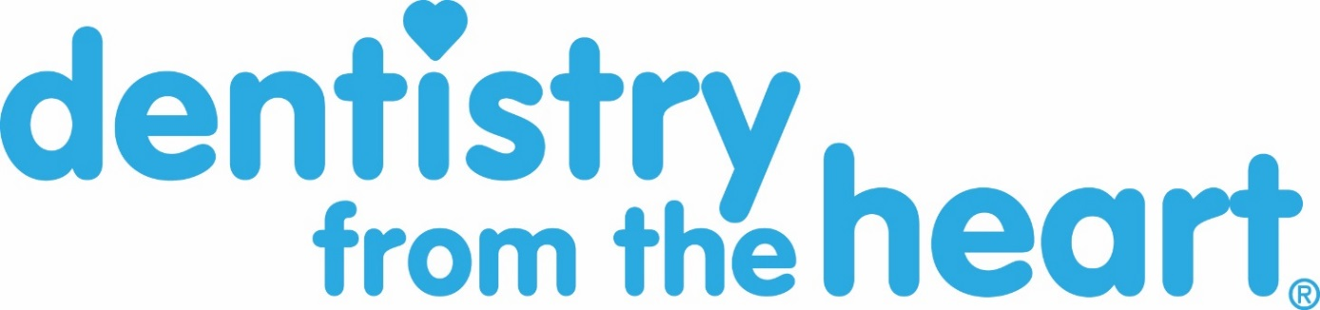

Hosted by Dr. Douglas J. Snyder
FREE DENTAL CARE
SATURDAY, MAY 21, 2016
Event Hours: 8am until 5pm

This is the day when we give back to a community that has been so wonderful to us.
Choice of either a filling, extraction, or cleaning will be performed for those 18 years and older.
- ARRIVE EARLY – REGISTRATION STARTS AT 7:30am.
- Please park at Work One across the street.
- Patients will be seen on a first-come, first served basis.
Dress appropriately for the weather. We will provide tables and chairs. We will also provide breakfast items and snacks throughout the day.

Located at the offices of Douglas J. Snyder and Jeffrey Steele/ Michael Reider
423/ 427 Waterfall Drive, Elkhart, IN
